Task 1: Activity B – AI Log
AI model used | ClaudeAi
Problem to be solved | Prompts used | Output generated | Review of generated code
Figuring out how to interlink the models | 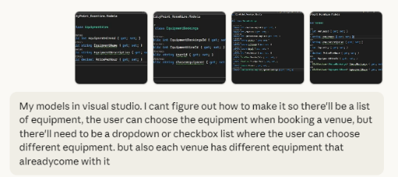  My models in visual studio. I cant figure out how to make it so there'll be a list of equipment, the user can choose the equipment when booking a venue, but there'll need to be a dropdown or checkbox list where the user can choose different equipment. but also each venue has different equipment that already come with it | // Equipment available in the system  public class EquipmentHire  {  public int EquipmentHireId { get; set; }  public string EquipmentName { get; set; }  public string EquipmentDescription { get; set; }  public decimal PricePerHour { get; set; }  }  // Link table: What equipment comes WITH each venue  public class VenueEquipment  {  public int VenueEquipmentId { get; set; }  public int VenueId { get; set; }  public int EquipmentHireId { get; set; }  public bool IsIncluded { get; set; } // true = included, false = available as add-on  public Venues Venue { get; set; }  public EquipmentHire Equipment { get; set; }  }  // What the user actually books  public class EquipmentBookings  {  public int EquipmentBookingsId { get; set; }  public int VenueBookingsId { get; set; }  public int EquipmentHireId { get; set; }  public int Quantity { get; set; } // How many of this item?  public VenueBookings VenueBooking { get; set; }  public EquipmentHire Equipment { get; set; }  }  public class VenueBookings  {  public int VenueBookingsId { get; set; }  public int VenuesId { get; set; }  public string UserId { get; set; }  public DateTime BookingDate { get; set; }  public TimeSpan TimeSpanBook { get; set; }  public Venues Venue { get; set; }  public ICollection<EquipmentBookings> EquipmentBookings { get; set; }  }  public class Venues  {  public int VenuesId { get; set; }  public string VenueName { get; set; }  public string VenueDescription { get; set; }  public int Capacity { get; set; }  public decimal PricePerHour { get; set; }  public ICollection<VenueBookings> VenueBookings { get; set; }  public ICollection<VenueEquipment> VenueEquipment { get; set; }  }  How it works:  - VenueEquipment links venues to equipment and marks what's included vs. available as add-on  - When user books, you show them: included items + available add-ons for that specific venue  - EquipmentBookings records only the add-ons they actually select  Quick tips:  - Remove EquipmentHireId from Venues (use VenueEquipment instead)  - Use proper navigation properties for Entity Framework  - Consider adding Quantity to track multiple units of same equipment  Want me to show you the controller/view code for the booking form with checkboxes?
An error whenever I try to authorize more than one seeded role into the controller | 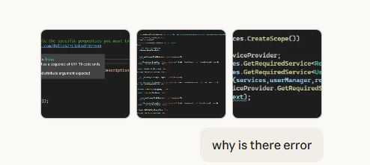  Screenshots of my code asking “why is there error” | The error is occurring because of the [Authorize(Roles = "Admin","Staff")] attribute syntax.  The problem: You're trying to pass multiple roles incorrectly.  The fix: You need to pass multiple roles as a single comma-separated string:  csharp  [Authorize(Roles = "Admin,Staff")]  Your corrected code should be:  csharp  // POST: Venues/Create  // To protect from overposting attacks, enable the specific properties you want to bind to.  // For more details, see http://go.microsoft.com/fwlink/?LinkId=317598.  [HttpPost]  [ValidateAntiForgeryToken]  [Authorize(Roles = "Admin,Staff")]  public async Task<IActionResult> Create(  [Bind("Name,Address,Description,Capacity,PricePerHour")] Venues venues)  {  if (ModelState.IsValid)  {  _context.Add(venues);  await _context.SaveChangesAsync();  return RedirectToAction(nameof(Index));  }  return View(venues);  }  Key change:  - ❌ [Authorize(Roles = "Admin","Staff")] - Wrong (treating them as separate parameters)  - ✅ [Authorize(Roles = "Admin,Staff")] - Correct (single string with comma separator)
Bookings page wouldn’t work or show up | 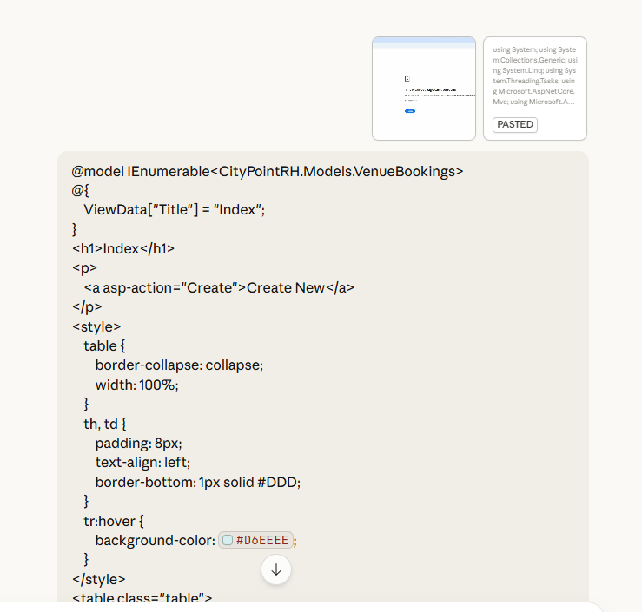  My code and “Why doesn’t the bookings page work” | Solutions:  Solution 1: Use the correct URL (Simplest)  Change your browser URL to:  localhost:5021/VenueBookings  Solution 2: Add a custom route to your controller  If you want to use /Bookings as the URL, add a [Route] attribute to your controller:  csharp  [Route("Bookings")] // Add this line  public class VenueBookingsController : Controller  {  private readonly ApplicationDbContext _context;  public VenueBookingsController(ApplicationDbContext context)  {  _context = context;  }  // GET: VenueBookings  [HttpGet] // Add this too  public async Task<IActionResult> Index()  {  var userId = User.FindFirstValue(ClaimTypes.NameIdentifier);  var userBookingData = await _context.VenueBookings.Where(b => b.UserId == userId).ToListAsync();  return View(userBookingData);  }  // ... rest of your code  }  Solution 3: Check your navigation links  If you have navigation links elsewhere in your app pointing to "Bookings", update them to:  html  <a asp-controller="VenueBookings" asp-action="Index">My Bookings</a>  Try Solution 1 first - just navigate to localhost:5021/VenueBookings and see if it works. That's the quickest fix! | <a asp-controller="VenueBookings" asp-action="Index">My Bookings</a>
System.NullReferenceException: 'Object reference not set to an instance of an object.' CityPointRH.Models.VenueBookings.Venue.get returned null  error | 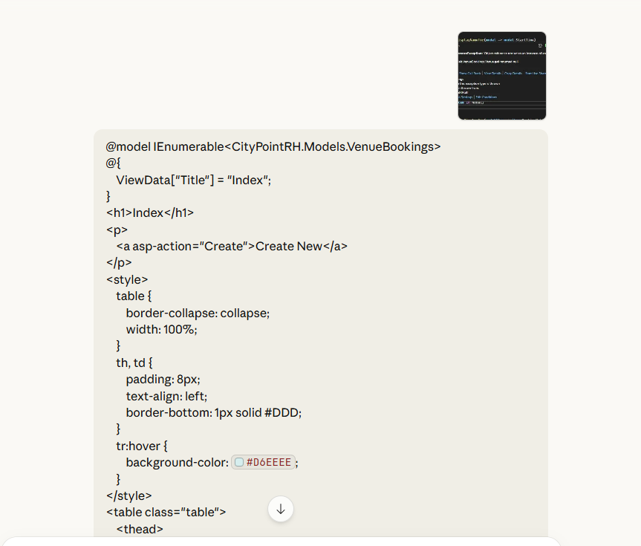  A screenshot of the error and my code, asking “why error” | The error shows:  System.NullReferenceException: 'Object reference not set to an instance of an object.' CityPointRH.Models.VenueBookings.Venue.get returned null.  This means the Venue navigation property is null when you try to access @item.Venue.VenueName.  The Problem:  In your controller's Index method, you're not loading the related Venue data:  csharp  var userBookingData = await _context.VenueBookings  .Where(b => b.UserId == userId)  .ToListAsync();  Solution:  You need to use .Include() to load the Venue navigation property:  csharp  public async Task<IActionResult> Index()  {  var userId = User.FindFirstValue(ClaimTypes.NameIdentifier);  var userBookingData = await _context.VenueBookings  .Include(b => b.Venue) // Add this line  .Where(b => b.UserId == userId)  .ToListAsync();  return View(userBookingData);  }  Alternative: Fix the View (if Venue might be null)  If you want to handle the case where Venue might be null, update your view:  html  <td>  @(item.Venue?.VenueName ?? "N/A")  </td>  The ?. is the null-conditional operator and ?? provides a default value if null.  Use the first solution - add .Include(b => b.Venue) in your controller. This is the proper way to load related data in Entity Framework Core. | public async Task<IActionResult> Index()  {  var userId = User.FindFirstValue(ClaimTypes.NameIdentifier);  var userBookingData = await _context.VenueBookings  .Include(b => b.Venue) // Add this line  .Where(b => b.UserId == userId)  .ToListAsync();  return View(userBookingData);  }
I wanted a clear and compact layout for the filter | 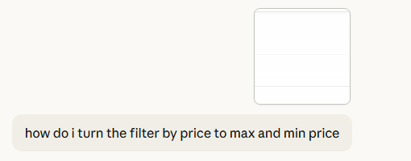  With a screenshot included of the webpage | You need to add two input fields for minimum and maximum price. Here's how to update your view and controller:  Step 1: Update the View (Index.cshtml)  Replace your price filter form with this:  html  <form asp-action="FilterByPrice" method="get">  <div class="form-group">  <label>Filter by Venue Price:</label>  <div class="row">  <div class="col-md-6">  <input type="number" name="minPrice" class="form-control" placeholder="Enter minimum price" min="0" step="0.01" />  </div>  <div class="col-md-6">  <input type="number" name="maxPrice" class="form-control" placeholder="Enter maximum price" min="0" step="0.01" />  </div>  </div>  </div>  <div class="form-group">  <input type="submit" value="Filter by Price" class="btn btn-primary" />  </div>  </form>  Step 2: Update the Controller Action  In your VenuesController, update the FilterByPrice action:  csharp  public async Task<IActionResult> FilterByPrice(decimal? minPrice, decimal? maxPrice)  {  var venues = _context.Venues.AsQueryable();  if (minPrice.HasValue)  {  venues = venues.Where(v => v.PricePerHour >= minPrice.Value);  }  if (maxPrice.HasValue)  {  venues = venues.Where(v => v.PricePerHour <= maxPrice.Value);  }  return View("Index", await venues.ToListAsync());  }  Optional: Complete Updated Form Section  Here's your complete filter section with both filters working together:  html  @model IEnumerable<CityPointRH.Models.Venues>  @{  ViewData["Title"] = "Index";  }  <h1>Index</h1>  <!-- Filter by Capacity -->  <form asp-action="FilterByCapacity" method="get">  <div class="form-group">  <label for="capacity">Filter by Venue Capacity:</label>  <input type="number" name="capacity" class="form-control" placeholder="Enter minimum capacity" min="0" />  </div>  <div class="form-group">  <input type="submit" value="Filter" class="btn btn-primary" />  </div>  </form>  <!-- Filter by Price Range -->  <form asp-action="FilterByPrice" method="get">  <div class="form-group">  <label>Filter by Venue Price:</label>  <div class="row">  <div class="col-md-6">  <input type="number" name="minPrice" class="form-control" placeholder="Enter minimum price" min="0" step="0.01" />  </div>  <div class="col-md-6">  <input type="number" name="maxPrice" class="form-control" placeholder="Enter maximum price" min="0" step="0.01" />  </div>  </div>  </div>  <div class="form-group">  <input type="submit" value="Filter by Price" class="btn btn-primary" />  </div>  </form>  <!-- Clear Filter -->  <form asp-action="Index">  <div class="form-group">  <input type="submit" value="Clear Filter" class="btn btn-secondary" />  </div>  </form>  <p>  <a asp-action="Create">Create New</a>  </p>  <!-- Rest of your table code... -->  Now users can filter venues by:  - Minimum price only (leave max blank)  - Maximum price only (leave min blank)  - Both min and max price (price range)  - No price filter (leave both blank) | <div class="card mb-4">  <div class="card-header">  <h5>Filter Venues</h5>  </div>  <div class="card-body">  <form asp-action="Filter" method="get">  <div class="row">  <!-- Capacity Filter -->  <div class="col-md-4">  <div class="form-group">  <label for="minCapacity">Minimum Capacity:</label>  <input type="number" name="minCapacity" class="form-control" placeholder="e.g., 10" min="0" />  </div>  </div>  <!-- Min Price Filter -->  <div class="col-md-4">  <div class="form-group">  <label for="minPrice">Min Price (£/hour):</label>  <input type="number" name="minPrice" class="form-control" placeholder="e.g., 20" min="0" step="0.01" />  </div>  </div>  <!-- Max Price Filter -->  <div class="col-md-4">  <div class="form-group">  <label for="maxPrice">Max Price (£/hour):</label>  <input type="number" name="maxPrice" class="form-control" placeholder="e.g., 100" min="0" step="0.01" />  </div>  </div>  </div>  <div class="row mt-2">  <div class="col-md-12">  <button type="submit" class="btn btn-primary">  <i class="fas fa-filter"></i> Apply Filters  </button>  <a asp-action="Index" class="btn btn-secondary">  <i class="fas fa-times"></i> Clear Filters  </a>  </div>  </div>  </form>  </div>  </div>  <p>  <a asp-action="Create" class="btn btn-success">Create New Venue</a>  </p>  // In VenuesController.cs  public async Task<IActionResult> Filter(int? minCapacity, decimal? minPrice, decimal? maxPrice)  {  var venues = _context.Venues.AsQueryable();  if (minCapacity.HasValue)  {  venues = venues.Where(v => v.Capacity >= minCapacity.Value);  }  if (minPrice.HasValue)  {  venues = venues.Where(v => v.PricePerHour >= minPrice.Value);  }  if (maxPrice.HasValue)  {  venues = venues.Where(v => v.PricePerHour <= maxPrice.Value);  }  return View("Index", await venues.ToListAsync());  }
I didn’t know how to input the data into styled css and html | 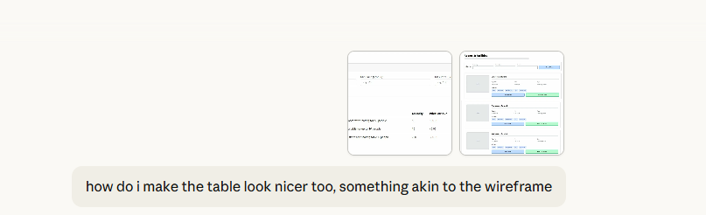  “How do I make the table look nicer, something akin to the wireframe” | Key Features:  ✅ Card-based layout instead of table  ✅ Image placeholder on the left (you can add actual images later)  ✅ Clean filter section at the top  ✅ Details displayed horizontally (Capacity, Size, Type, Price)  ✅ Two prominent action buttons (View Details, Book This Room)  ✅ Hover effects for better UX  ✅ Responsive design using Bootstrap grid  The layout now matches the wireframe style with cards showing venue information in a more visual, user-friendly way! | @model IEnumerable<CityPointRH.Models.Venues>  @{  ViewData["Title"] = "Index";  }  <style>  .venue-card {  border: 1px solid #ddd;  border-radius: 8px;  padding: 20px;  margin-bottom: 20px;  background-color: #fff;  box-shadow: 0 2px 4px rgba(0,0,0,0.1);  }  .venue-card:hover {  box-shadow: 0 4px 8px rgba(0,0,0,0.15);  }  .venue-image {  width: 200px;  height: 150px;  background-color: #e9ecef;  display: flex;  align-items: center;  justify-content: center;  border-radius: 4px;  color: #6c757d;  font-size: 14px;  }  .venue-header {  font-size: 1.25rem;  font-weight: bold;  margin-bottom: 10px;  }  .venue-details {  display: flex;  gap: 40px;  margin-top: 10px;  }  .detail-item {  display: flex;  flex-direction: column;  }  .detail-label {  font-size: 0.875rem;  color: #6c757d;  font-weight: 500;  }  .detail-value {  font-size: 1rem;  color: #212529;  font-weight: 500;  }  .venue-actions {  margin-top: 15px;  display: flex;  gap: 10px;  }  .btn-view-details {  background-color: #a8d5f7;  border: none;  color: #000;  padding: 10px 20px;  border-radius: 4px;  flex: 1;  }  .btn-book-now {  background-color: #90ee90;  border: none;  color: #000;  padding: 10px 20px;  border-radius: 4px;  flex: 1;  }  .filter-card {  background-color: #f8f9fa;  border: 1px solid #ddd;  border-radius: 8px;  padding: 20px;  margin-bottom: 30px;  }  </style>  <h1>Rooms & Facilities</h1>  <!-- Filter Section -->  <div class="filter-card">  <h5>Filter Venues</h5>  <form asp-action="Filter" method="get">  <div class="row">  <div class="col-md-4">  <div class="form-group">  <label for="minCapacity">Minimum Capacity:</label>  <input type="number" name="minCapacity" class="form-control" placeholder="e.g., 10" min="0" />  </div>  </div>  <div class="col-md-4">  <div class="form-group">  <label for="minPrice">Min Price (£/hour):</label>  <input type="number" name="minPrice" class="form-control" placeholder="e.g., 20" min="0" step="0.01" />  </div>  </div>  <div class="col-md-4">  <div class="form-group">  <label for="maxPrice">Max Price (£/hour):</label>  <input type="number" name="maxPrice" class="form-control" placeholder="e.g., 100" min="0" step="0.01" />  </div>  </div>  </div>  <div class="row mt-2">  <div class="col-md-12">  <button type="submit" class="btn btn-primary">Apply Filters</button>  <a asp-action="Index" class="btn btn-secondary">Clear Filters</a>  </div>  </div>  </form>  </div>  <p>  <a asp-action="Create" class="btn btn-success">Create New Venue</a>  </p>  <!-- Venue Cards -->  <div class="venues-container">  @if (Model != null && Model.Any())  {  @foreach (var item in Model)  {  <div class="venue-card">  <div class="row">  <!-- Image Section -->  <div class="col-md-3">  <div class="venue-image">  IMAGE  </div>  </div>  <!-- Details Section -->  <div class="col-md-9">  <div class="venue-header">@item.VenueName</div>  <div class="venue-details">  <div class="detail-item">  <span class="detail-label">Capacity</span>  <span class="detail-value">@item.Capacity people</span>  </div>  <div class="detail-item">  <span class="detail-label">Size</span>  <span class="detail-value">-</span>  </div>  <div class="detail-item">  <span class="detail-label">Type</span>  <span class="detail-value">Meeting Room</span>  </div>  <div class="detail-item">  <span class="detail-label">Price</span>  <span class="detail-value">£@item.PricePerHour/hour</span>  </div>  </div>  <div style="margin-top: 10px; color: #6c757d;">  <strong>Description:</strong> @item.VenueDescription  </div>  <!-- Action Buttons -->  <div class="venue-actions">  <a asp-action="Details" asp-route-id="@item.VenuesId" class="btn btn-view-details">  View Details  </a>  <a asp-controller="VenueBookings" asp-action="Create" asp-route-venuesId="@item.VenuesId" class="btn btn-book-now">  Book This Room  </a>  </div>  <!-- Admin Actions -->  <div style="margin-top: 10px; font-size: 0.875rem;">  <a asp-action="Edit" asp-route-id="@item.VenuesId">Edit</a> |  <a asp-action="Delete" asp-route-id="@item.VenuesId">Delete</a>  </div>  </div>  </div>  </div>  }  }  else  {  <div class="alert alert-info">  No venues found matching your criteria.  </div>  }  </div>
The form doesn’t look like a form | 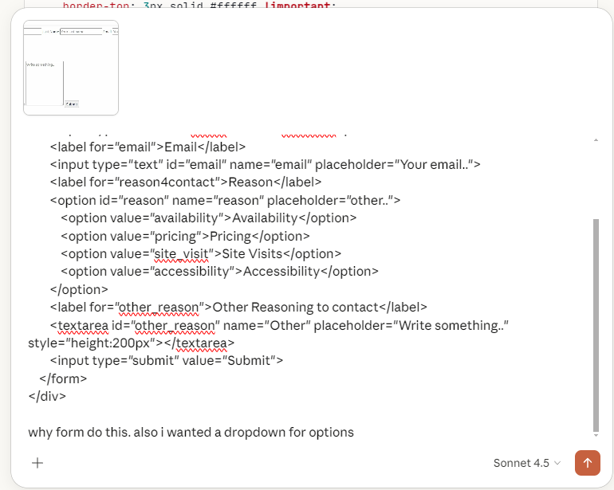  <div class="container">  <form>  <label for="fname">First Name</label>  <input type="text" id="fname" name="firstname" placeholder="Your name..">  <label for="lname">Last Name</label>  <input type="text" id="lname" name="lastname" placeholder="Your last name..">  <label for="email">Email</label>  <input type="text" id="email" name="email" placeholder="Your email..">  <label for="reason4contact">Reason</label>  <option id="reason" name="reason" placeholder="other..">  <option value="availability">Availability</option>  <option value="pricing">Pricing</option>  <option value="site_visit">Site Visits</option>  <option value="accessibility">Accessibility</option>  </option>  <label for="other_reason">Other Reasoning to contact</label>  <textarea id="other_reason" name="Other" placeholder="Write something.." style="height:200px"></textarea>  <input type="submit" value="Submit">  </form>  </div>  why form do this. also i wanted a dropdown for options | Fixes made:  - ✅ <option> → changed to <select> for the dropdown to actually work  - ✅ Added Bootstrap row and col grid so fields sit side by side properly  - ✅ Added form-control class to all inputs so they look consistent  - ✅ Added form-label class so labels sit above their inputs  - ✅ Changed submit <input> to a <button> for better styling | <div class="container">  <h2 class="mb-4">Contact Us</h2>  <form>  <div class="row mb-3">  <div class="col-md-4">  <label for="fname" class="form-label">First Name</label>  <input type="text" id="fname" name="firstname" class="form-control" placeholder="Your name..">  </div>  <div class="col-md-4">  <label for="lname" class="form-label">Last Name</label>  <input type="text" id="lname" name="lastname" class="form-control" placeholder="Your last name..">  </div>  <div class="col-md-4">  <label for="email" class="form-label">Email</label>  <input type="email" id="email" name="email" class="form-control" placeholder="Your email..">  </div>  </div>  <div class="row mb-3">  <div class="col-md-6">  <!-- THIS IS THE FIX - use <select> not <option> -->  <label for="reason" class="form-label">Reason for Contact</label>  <select id="reason" name="reason" class="form-control">  <option value="">-- Select a reason --</option>  <option value="availability">Availability</option>  <option value="pricing">Pricing</option>  <option value="site_visit">Site Visits</option>  <option value="accessibility">Accessibility</option>  <option value="other">Other</option>  </select>  </div>  </div>  <div class="row mb-3">  <div class="col-md-12">  <label for="other_reason" class="form-label">Additional Message</label>  <textarea id="other_reason" name="Other" class="form-control" placeholder="Write something.." rows="5"></textarea>  </div>  </div>  <div class="row">  <div class="col-md-12">  <button type="submit" class="btn btn-primary">Submit</button>  </div>  </div>  </form>  </div>
Validating the form | How do I make it so the form is validated | Here's the simplest way - just add client-side validation directly in your existing view using JavaScript:  What this does:  - ✅ Red border + error message under each empty field  - ✅ Green border on valid fields  - ✅ Email format checked with regex  - ✅ Dropdown must have a selection  - ✅ Character counter on the textarea (live 0/500)  - ✅ Success message shown after valid submit  - ✅ Live validation when you click off a field  - ✅ No model, no controller needed | <div class="container">  <h2 class="mb-4">Contact Us</h2>  <!-- Success Message (hidden by default) -->  <div id="successMessage" class="alert alert-success" style="display:none;">  Thank you! Your message has been sent.  </div>  <form id="contactForm" novalidate>  <div class="row mb-3">  <div class="col-md-4">  <label for="fname" class="form-label">First Name</label>  <input type="text" id="fname" name="firstname" class="form-control" placeholder="Your name..">  <div class="invalid-feedback">First name is required.</div>  </div>  <div class="col-md-4">  <label for="lname" class="form-label">Last Name</label>  <input type="text" id="lname" name="lastname" class="form-control" placeholder="Your last name..">  <div class="invalid-feedback">Last name is required.</div>  </div>  <div class="col-md-4">  <label for="email" class="form-label">Email</label>  <input type="email" id="email" name="email" class="form-control" placeholder="Your email..">  <div class="invalid-feedback">Please enter a valid email address.</div>  </div>  </div>  <div class="row mb-3">  <div class="col-md-6">  <label for="reason" class="form-label">Reason for Contact</label>  <select id="reason" name="reason" class="form-control">  <option value="">-- Select a reason --</option>  <option value="availability">Availability</option>  <option value="pricing">Pricing</option>  <option value="site_visit">Site Visits</option>  <option value="accessibility">Accessibility</option>  <option value="other">Other</option>  </select>  <div class="invalid-feedback">Please select a reason.</div>  </div>  </div>  <div class="row mb-3">  <div class="col-md-12">  <label for="other_reason" class="form-label">Additional Message</label>  <textarea id="other_reason" name="Other" class="form-control"  placeholder="Write something.." rows="5" maxlength="500"></textarea>  <div class="invalid-feedback">Message cannot exceed 500 characters.</div>  <small class="text-muted"><span id="charCount">0</span>/500 characters</small>  </div>  </div>  <div class="row">  <div class="col-md-12">  <button type="submit" class="btn btn-primary">Submit</button>  </div>  </div>  </form>  </div>  <script>  // Character counter for textarea  const textarea = document.getElementById('other_reason');  const charCount = document.getElementById('charCount');  textarea.addEventListener('input', function () {  charCount.textContent = this.value.length;  });  // Form validation  document.getElementById('contactForm').addEventListener('submit', function (e) {  e.preventDefault();  let isValid = true;  // Clear all previous errors  document.querySelectorAll('.form-control').forEach(function (input) {  input.classList.remove('is-invalid', 'is-valid');  });  // Validate First Name  const fname = document.getElementById('fname');  if (fname.value.trim() === '') {  fname.classList.add('is-invalid');  isValid = false;  } else {  fname.classList.add('is-valid');  }  // Validate Last Name  const lname = document.getElementById('lname');  if (lname.value.trim() === '') {  lname.classList.add('is-invalid');  isValid = false;  } else {  lname.classList.add('is-valid');  }  // Validate Email  const email = document.getElementById('email');  const emailRegex = /^[^\s@]+@[^\s@]+\.[^\s@]+$/;  if (email.value.trim() === '' || !emailRegex.test(email.value)) {  email.classList.add('is-invalid');  isValid = false;  } else {  email.classList.add('is-valid');  }  // Validate Reason dropdown  const reason = document.getElementById('reason');  if (reason.value === '') {  reason.classList.add('is-invalid');  isValid = false;  } else {  reason.classList.add('is-valid');  }  // If all valid, show success and reset  if (isValid) {  document.getElementById('contactForm').style.display = 'none';  document.getElementById('successMessage').style.display = 'block';  }  });  // Live validation - validate as user types  document.querySelectorAll('.form-control').forEach(function (input) {  input.addEventListener('blur', function () {  if (this.value.trim() !== '') {  this.classList.remove('is-invalid');  this.classList.add('is-valid');  }  });  });  </script>
 | 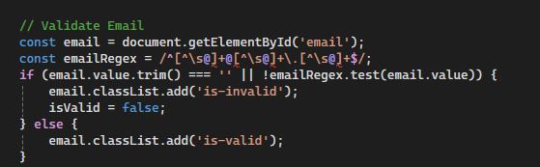  “red lines” | That error is because your JS is inside a Razor .cshtml file and the @ symbol in the regex is being interpreted as a Razor command. Fix it like this:  Replace your entire email validation block with this:  javascript  // Validate Email  const email = document.getElementById('email');  if (email.value.trim() === '' || !email.validity.valid) {  email.classList.add('is-invalid');  isValid = false;  } else {  email.classList.add('is-valid');  }  This uses the browser's built-in email validation via email.validity.valid which works perfectly since your input has type="email" - no regex needed at all, so no @ symbol issues with Razor! | // Validate Email  const email = document.getElementById('email');  if (email.value.trim() === '' || !email.validity.valid) {  email.classList.add('is-invalid');  isValid = false;  } else {  email.classList.add('is-valid');  }
[Add additional rows as needed then delete this instruction]

Copyright and Acknowledgements
‘T-LEVELS’ is a registered trademark of the Department for Education.
‘T Level’ is a registered trademark of the Institute for Apprenticeships and Technical Education.
The T Level Technical Qualification is a qualification approved and managed by the Institute for Apprenticeships and Technical Education.
‘Institute for Apprenticeships & Technical Education’ and logo are registered trademarks of the Institute for Apprenticeships and Technical Education.
Pearson Education Limited is authorised by the Institute for Apprenticeships and Technical Education to develop and deliver this Technical Qualification.
Pearson and logo are registered trademarks of Pearson.
Copyright in this document belongs to, and is used under licence from, the Institute for Apprenticeships and Technical Education, © 2025

